On-going research about CH4 sensor project

Methane

- Naturally present in soil, water, and the atmosphere
- Released by human activities (agriculture, one of the largest methane producers), including rice paddies
- Constitutes 60% of natural gas fossil deposits
- Produced by forced anaerobic fermentation (intentional decomposition of organic matter to produce gas, mainly methane)
- Uses: electricity, heating, automotive fuel
- Highly flammable in air (R12) and explosive

Environmental Impact

- Contributes to global warming as a greenhouse gas, absorbing part of the infrared radiation emitted by the Earth and preventing it from escaping into space
- Second most important greenhouse gas in the atmosphere after water vapor
- Sources of emissions:
- Anaerobic fermentation underwater (in natural or artificial wetlands, particularly rice paddies and hydroelectric dams that have flooded forests or accumulated significant organic matter)
- Fossil fuels

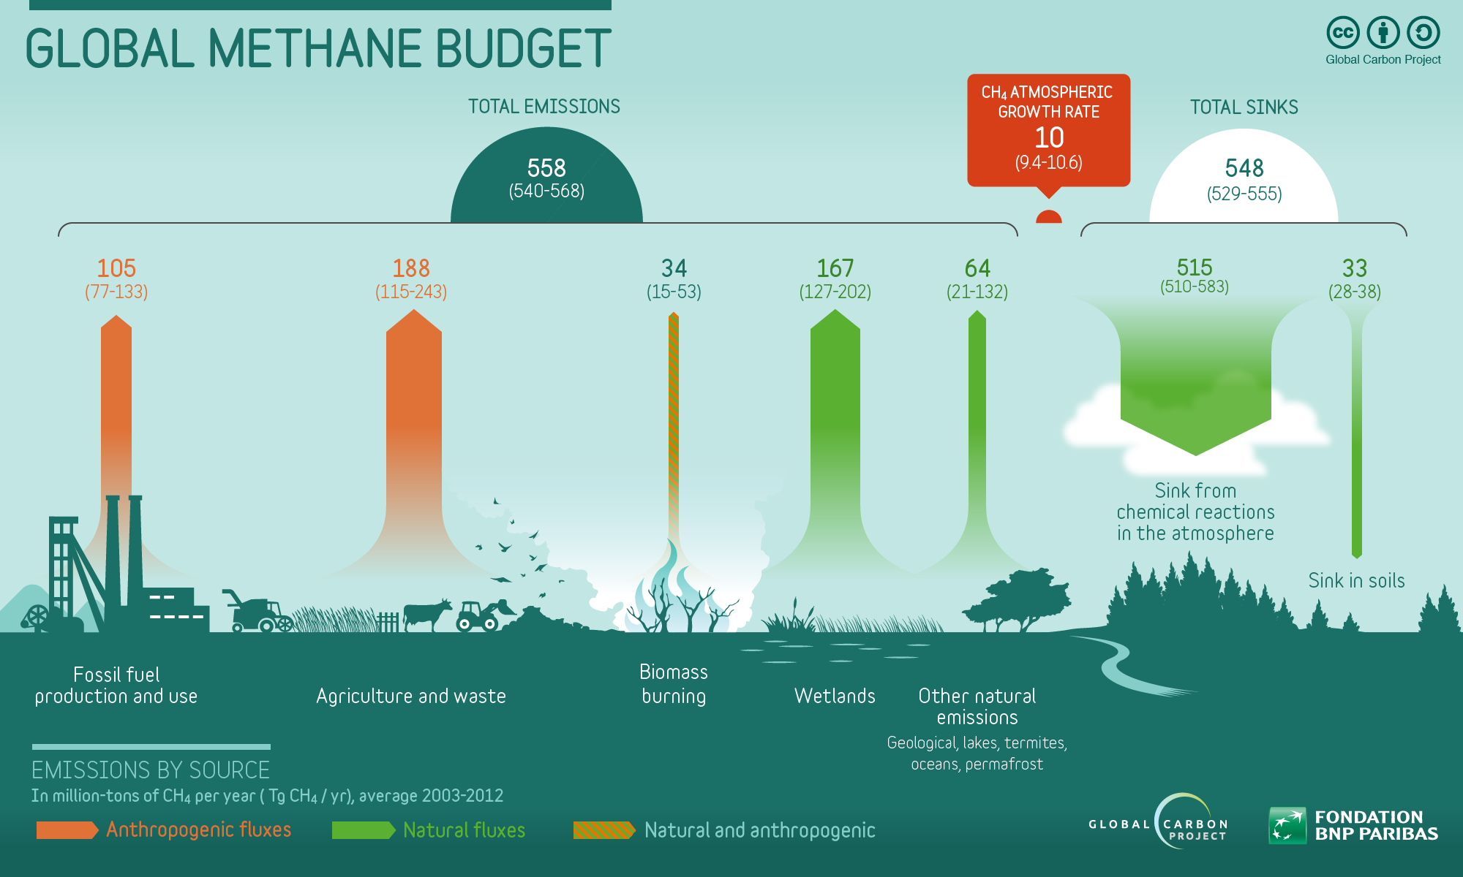
Detection

- Measured via satellite or on-site sensors
- Objective: Reducing methane emissions is more cost-effective and efficient for mitigating global warming compared to reducing CO2

Mitigation Strategies

- Sensors + burning or distillation purification of CH4 emissions => CO2 emission, a less potent greenhouse gas
- Modify cattle diets
- Rice cultivation: reduce fertilizer use, combat water turbidity, and reduce methanogenic sediment production

Methane Concentration in Rice Fields

- The concentration of CH4 in the air above a rice field can range from 23 ppmv (parts per million by volume) in the early morning to 1.75 ppmv later in the day
- Source: https://horizon.documentation.ird.fr/exl-doc/pleins_textes/pleins_textes_7/b_fdi_55-56/010022343.pdf

Gas Sensor Functionality

Types of Gas Sensors :

- Electrochemical Sensors: Used to detect gases like carbon monoxide (CO) and sulfur dioxide (SO2). They measure the electrical current resulting from a chemical reaction between the gas and an electrode.
- Semiconductor Sensors: Sensitive to a wide range of gases. These sensors change conductivity in the presence of specific gases, allowing for their detection.
- Infrared Sensors: Detect gases like methane (CH4) and carbon dioxide (CO2) by measuring the absorption of infrared light by gas molecules.
- Source: https://www.electricity-magnetism.org/fr/capteurs-de-gaz/

Market-Available Sensors

- MQ4:
- Datasheet available in the folder
- Detection range: 200-10000 ppm CH4, natural gas
- Not precise enough
- Example: https://www.elecbee.com/en-25216-3pcs-MQ-4-Methane-Natural-Gas-Sensor-Module-Shield-Liquefied-Electronic-Detector-Module-for-Arduino-products-that-work-with-official-Arduino-boards?network=g&campaign=18719854073&adgroup=140153146062&creative=630917925115&keyword=&target=pla-296303633664&matchtype=&devicemodel=&placement=&feeditemid=&adpostition=&gad_source=1

- MQ6:
- Datasheet available in the folder
- Detection range: 300-10000 ppm (Propane)
- Not precise enough
- Example: https://www.mouser.vn/ProductDetail/SparkFun/SEN-09405?qs=WyAARYrbSnZOCcjS0fpUkg%3D%3D&mgh=1&srsltid=AfmBOopmhCaLzn83aMg1Dv8F3UZjHrgqhW39NmbDPme2XdtcsIMkjWGNDD4

- All MQ sensor datasheets:
- https://robu.in/mq-series-gas-sensor/
- None are sensitive enough

Research Results (Non-Commercialized)

- Low-Cost Detection of Methane Gas in Rice Cultivation :
- Method: Gas Chromatography-Flame Ionization Detector based on manual injection and split pattern
- Capable of detecting methane at a few ppm. Tests conducted on methane samples collected from low-emission rice fields yielded conclusive results
- Reference: https://ncbi.nlm.nih.gov/pmc/articles/PMC9267938/

- Highly Sensitive Sensor Detection in Parts-per-Billion:
- Source:
Schulich Researchers Article :
https://schulich.ucalgary.ca/news/schulich-researchers-develop-highly-sensitive-methane-sensor
ACS Sensors Article :
https://pubs.acs.org/doi/pdf/10.1021/acssensors.2c01796

Key Steps

Embedded Board
- Find a methane sensor suitable for this application
- Use a microprocessor to acquire data
- Transmit data to the cloud (via antenna, GSM module, etc.), stored on platforms like ThingSpeak

User's Phone
- Develop a mobile application to:
- Retrieve data sent by the sensor
- Process the data
- Display the results in real-time

Example of Necessary Equipment for Arduino Hardware
- A low-budget methane sensor (MQ4) with a broad detection range
- An Arduino board
- A GSM/3G network module (MKR GSM 1400) to connect the board to the cloud
- MKR GSM 1400 Documentation : https://docs.arduino.cc/hardware/mkr-gsm-1400/
- A transmitting antenna

On-site board

The device in the field must meet and be protected against certain conditions. This implies taking into account technical and environmental constraints to ensure proper operation.

The components The methane sensor tour was done earlier with the MQ sensor family.of the board are :
a methane sensor
a GSM/3G module
a battery
an autonomous battery charger
all controlled by an STM32 microcontroller

Methane sensors:

The methane sensor tour was done earlier with the MQ sensor family.

GSM module:

Once the data has been collected, you need to be able to access it remotely. One solution is to transmit the data to a cloud server and then retrieve it from another remote device.
Several devices are possible:
- a WiFi device, such as ESP8266 or ESP32
- a low-energy Bluetooth device, such as Nordic nRF52
- a LoRa device, such as RFM95
- a cellular device

The first 3 devices are frequently used for sensor networks. However, in order to connect to the cloud, these three devices are not sufficient on their own, and require a gateway.
In the case of a single sensor system, the cellular device seems more relevant. It's self-sufficient. However, this will no longer be viable on a large scale.

From now on, we'll consider a cellular device with a SIM card.
A low-cost, highly functional solution is the SIM module family ( ie SIM800, SIM900).
The module is optimized for low-power operation and can be battery-powered. It can be connected to the Internet via integrated TCP/IP protocol, thanks to a GPRS module.
However, there is a problem. The peak current required for data transmission via the GPRS module is around 2 A. A microcontroller card cannot deliver such a current.
A separate regulator or Li-Ion battery must be used for this module.

For example: https://www.alibaba.com/pla/103450-37v-1800mah-1900mah-2000mah-2500mah_1600554709079.html? mark=google_shopping&biz=pla&searchText=lithium+ion+batteries&product_id=1600554709079&pcy=US&src=sem_ggl&field=UG&from=sem_ggl&cmpgn=20559558214&adgrp=&fditm=&tgt=&locintrst=&locphyscl=1028580&mtchtyp=&ntwrk=x&device=c&dvcmdl=&creative=&plcmnt=&plcmntcat=&aceid=&position=&gad_source=1

This battery supplies 3.7 V (within the range required for the SIM800 module) and can deliver up to 2000 mA, i.e. 2 A.
This solution seems viable, but isn't really, as the battery has to be recharged, which doesn't seem optimal because of the two other batteries that have to be charged to power the board.
So we opt for a DC/DC regulator. Remember that the aim is, from a microcontroller output voltage, to have an input voltage for the GPRS module of between 3.4V and 4.4V, and to enable this same module to draw up to 2 A.
It's all possible with this regulator:
https://nshopvn.com/product/mach-nguon-giam-ap-dc-mini-3a/?gad_source=1

Microcontroller:

Now that we have an idea of the sensors and communication module, we need to decide which microcontroller to choose. In our case, power consumption, portability, resistance to environmental conditions and board autonomy take precedence over everything else.
Two categories of STM microcontrollers seem to fit the bill: STM32L0 and STM32L4.
The models selected are as follows: STM32L011K4, STM32L031K6 and STM32L476RG
All three are Ultra-Low Power microcontrollers. Their low current requirements and wide supply voltage range mean that the board and GSM module can be powered in parallel from a single source. These three microcontrollers are respectively integrated into the NUCLEO board of the same name (e.g. NUCLEO-LO11K4).

Power supply :

When it comes to powering the system, I'll be opting for a battery-powered system to ensure portability. What's more, to make the whole thing autonomous, we're adding a solar-powered charging system using the on-board solar cell.
I therefore need to supply the board with 3.3V, 5V or 7V.
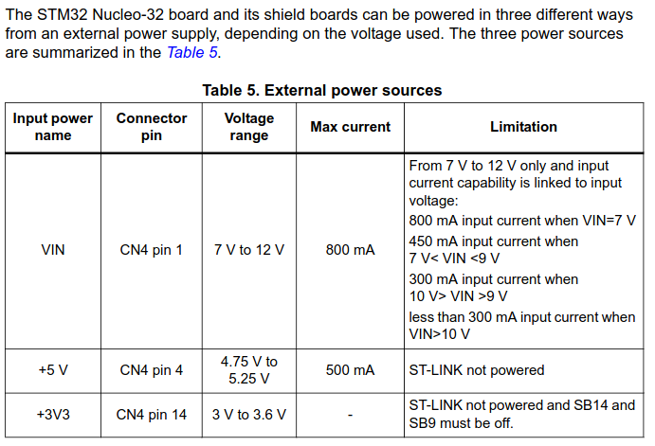
We'll use a Li-Ion battery to supply the board with 3.7V, 2000mAh.
To make the system autonomous, we could consider a two-battery relay module. The relay selects which battery is to be recharged.
In this way, one battery supplies the microcontroller board as long as its charge is above a minimum threshold, while the other is connected to the solar charger, which recharges it.
Once the charge of the supply battery is too low, the roles are exchanged via the relay. This ensures that the system is always powered up. To achieve this, we'll use 4 controlled relays acting as switches, like this one: https://nshopvn.com/product/module-8-relay-voi-opto-cach-ly-5vdc/?gad_source=1&gclid=Cj0KCQjwjLGyBhCYARIsAPqTz1_nvLT8R5FeBV-54BtboBjhoNkqD2BMC6BTETFfiRQZ6MRrk-Qg67saAgvnEALw_wcB
Here's a representative diagram:

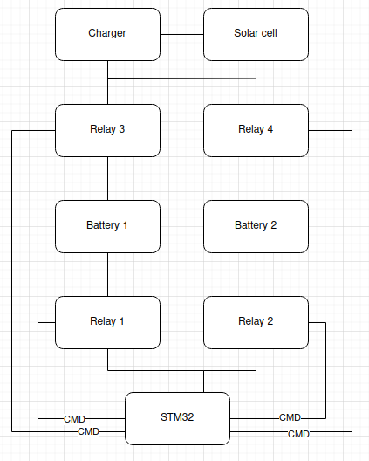

Charger and solar cell :

For the charger-solar cell assembly, we choose the following module: STEVAL-ISV012V1
This module has the advantage of considering the constraints of the battery, i.e. includes features to protect the battery against overcharging, deep discharge, and other potential problems. Combined with its low power consumption, its usefulness is crucial in my application.

Calcul of whole system max consumption :
When GPRS isn’t transmitting :
Board = 100mA
MQ4 sensor = 150mA
GPRS module = 200mA

Total = 450 mA
Battery capacity = 1850 mA
Cycle time = 4 hours

Fields are subject to numerous environmental constraints which the components of our application must be resistant to:

Temperature:

In the field, temperatures can range from very low to very high. The device must withstand temperature variations ranging from 0°C (for winter seasons) to 50°C (for summer seasons) including a 5°C margin.

Humidity:

The circuit must be resistant to humidity and rain to avoid circuit malfunctions such as short-circuiting or corrosion. We would need a device that can withstand more up to 95% humidity for the most humid regions of Vietnam.

Energy autonomy:

The card placed in a field must be autonomous, with no need for recurrent handling, and must be self-sufficient in terms of energy supply. It is therefore impossible to consider a power supply via rechargeable batteries that have to be changed manually. One solution would be to use renewable energies, such as solar power via solar panels or wind power.

Let's start by considering wind power as the card's power supply. In Vietnam, the strongest winds are found along the coast.
(cf Options for wind power in Vietnam by 2030, https://enpc.hal.science/hal-02329698v2)
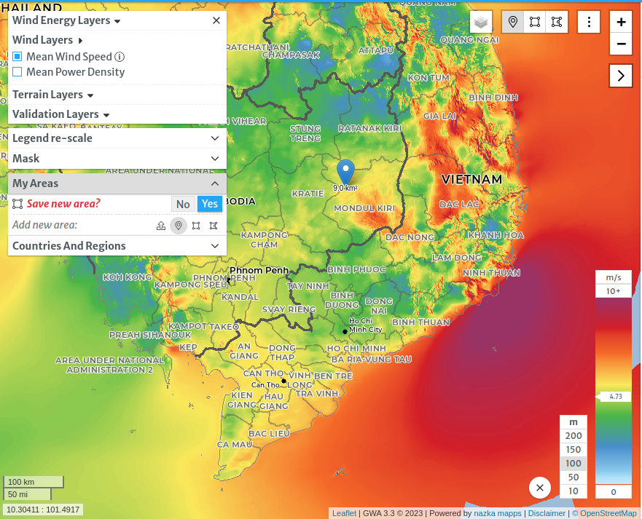
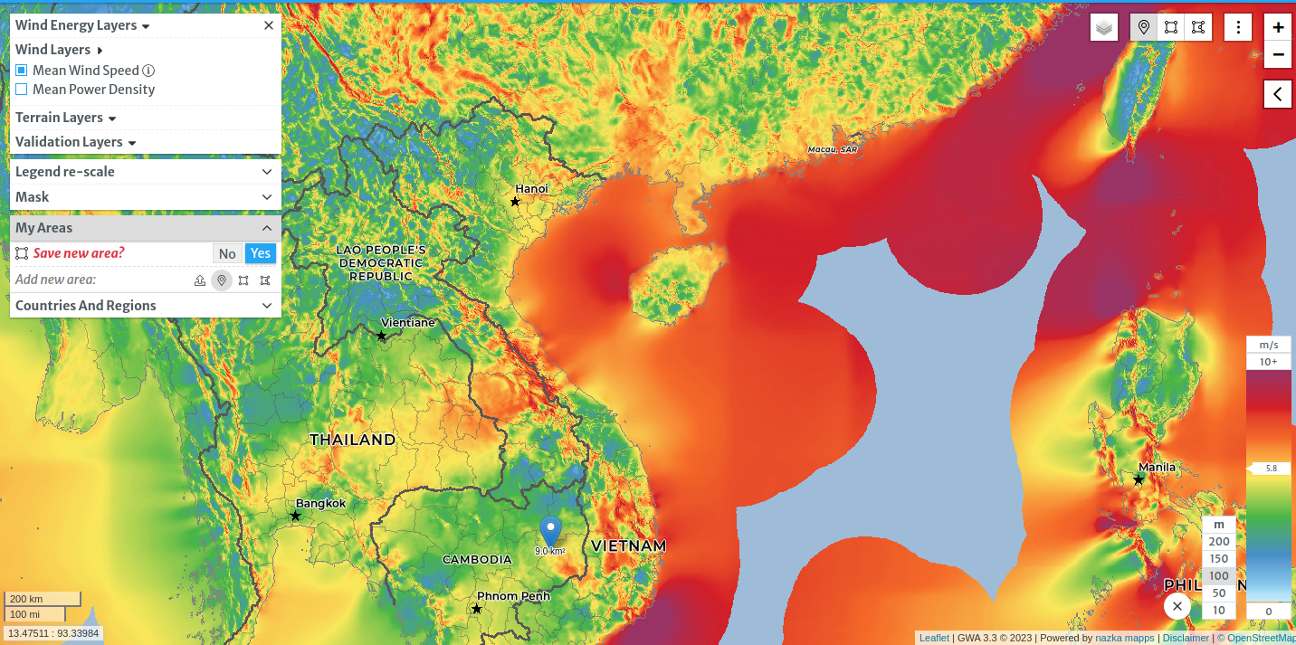

Screenshot from the Global Wind Atlas website, which shows average wind speeds in different regions.

Inland, only central Vietnam experiences strong winds. The rest of the country is rather calm. Nevertheless, if the fields are close enough to the coast, the efficiency of wind power could be relevant.

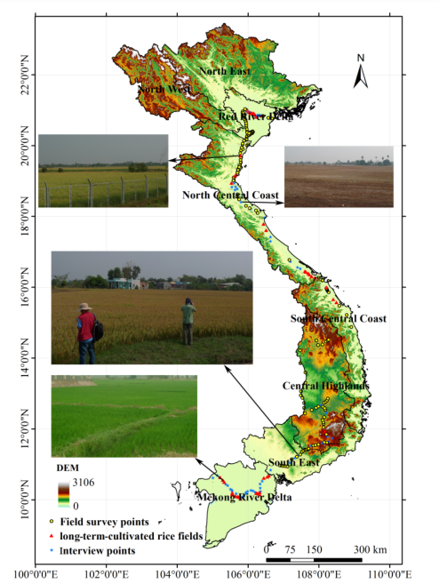

Representation of field density in Vietnam
cf Mapping Rice Cropping Systems in Vietnam https://www.researchgate.net/publication/289685070_Mapping_Rice_Cropping_Systems_in_Vietnam_Using_an_NDVI-Based_Time-Series_Similarity_Measurement_Based_on_DTW_Distance

This report shows the density of fields in Vietnam. The fields are concentrated in two main regions. Along Mekong Lake and in the Red River delta.
These two regions are among those inland where winds are strongest (between 5 and 10 m/s).

The wind turbine approach can be considered through a portable mini-wind turbine. A 3D model could be printed for the structure, fitted with a generator to convert motive power into electric current. This electric current could power a battery connected to the board. This approach is rather tedious, as it requires a wind strong enough to generate enough inertia to set the wind turbine blades in motion. This is not a certainty in areas where winds are at best 10m/s. This solution could be combined with a solar cell power supply at the end of the project.

Let's now consider a solar cell approach. This solution is all the more relevant as it is efficient due to the almost omniscient sunshine in Vietnam.
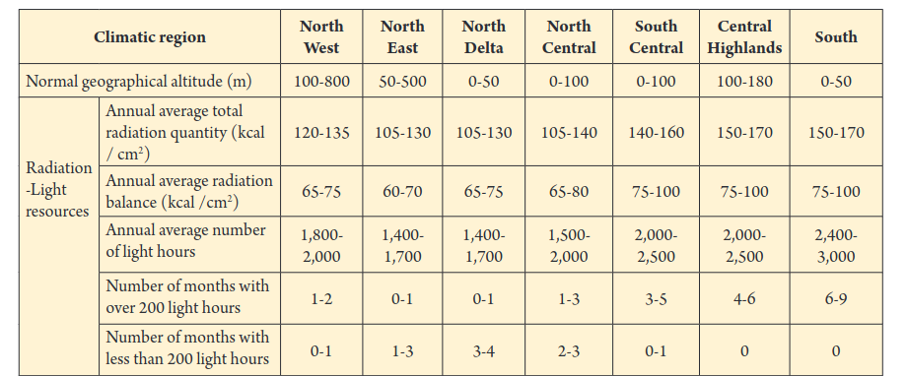

So, whatever the region, the average number of hours of sunshine per year is 1,400. That's an average of 4 hours of sunshine a day.

Low consumption microprocesser : STM32L0
https://www.st.com/en/microcontrollers-microprocessors/stm32-ultra-low-power-mcus.html
https://www.mouser.vn/ProductDetail/STMicroelectronics/STM32L010K4T6?qs=PqoDHHvF64%252BA8yN3WOJbRw%3D%3D&mgh=1&gad_source=1

Stockage d’energie via batterie lithium ion : 3.7V
https://www.alibaba.com/pla/lipo-452035-37V-300mAh-Primatic-lithium_1600384927857.html?mark=google_shopping&biz=pla&searchText=lithium+ion+batteries&product_id=1600384927857&pcy=US&src=sem_ggl&field=UG&from=sem_ggl&cmpgn=20559558214&adgrp=&fditm=&tgt=&locintrst=&locphyscl=1028580&mtchtyp=&ntwrk=x&device=c&dvcmdl=&creative=&plcmnt=&plcmntcat=&aceid=&position=&gad_source=1

Couplage d’un panneau solaire et d’une éolienne : https://www.alibaba.com/product-detail/Direct-selling-15w-small-wind-power_1600470217761.html?spm=a2700.pccps_detail.0.0.1b5613a0u1ZvD7

Pin du STM32l011k4 : https://os.mbed.com/platforms/ST-Nucleo-L011K4/

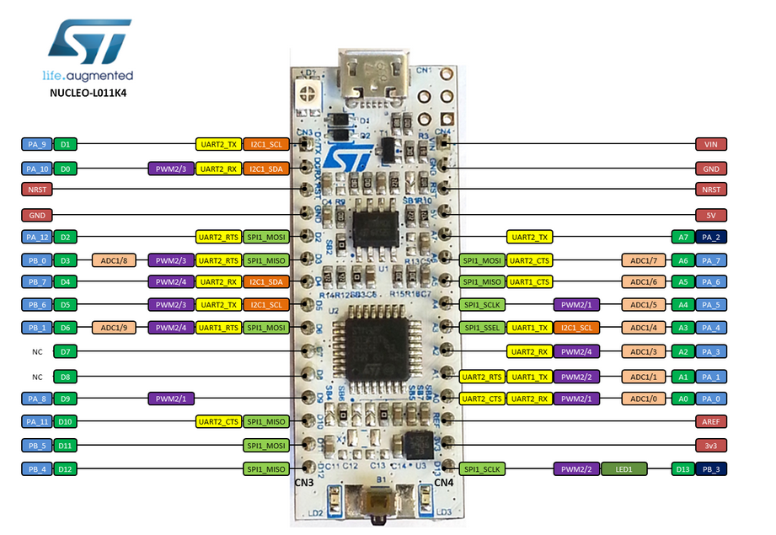
How to power Arduino with solar panel ?
https://www.sensingthecity.com/powering-arduino-uno-with-solar-cell/

https://lastminuteengineers.com/sim800l-gsm-module-arduino-tutorial/
https://predictabledesigns.com/the-sim800-cellular-module-and-arduino-a-powerful-iot-combo/
https://www.hackster.io/m_karim02/smoke-detection-using-mq-2-gas-sensor-df9e38
https://www.electroduino.com/sim800l-gsm-module/

DC/DC booster : https://linhkienvietnam.vn/module-tang-ap-dc-dc-xl6009-4a-3-32v-b3h14?variantId=73232551&gad_source=1

